Chester Public Library
Board of Trustees Meeting
Tuesday November 15, 2022, 6:30 pm
Agenda
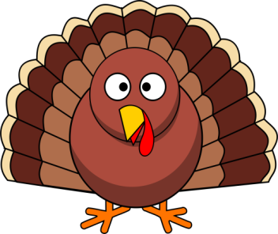

- Call to Order
- Attendance
- Review and Approval of agenda
- Secretary's Report
- Director’s Report
- Donations and Contributions
- Treasurer’s Report
- Approval of Expenditures and Incoming Checks
- Monthly Statistics
- Old Business:
- New Business:
- 2023 Holiday Calendar
- Plan next month’s agenda
- Next Meeting: December 20, 2022 at 6:30 pm
- Adjourn

