Chester Public Library
Board of Trustees Meeting
Tuesday November 16, 2021, 6:30 pm
Agenda
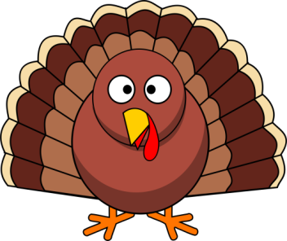

- Call to Order
- Attendance
- Review and Approval of agenda
- Secretary's Report
- Director’s Report
- Donations and Contributions
- Treasurer’s Report
- Approval of Expenditures and Incoming Checks
- Monthly Statistics
- Old Business:
- Donor tree
- New Business:
- Permission to close library at 6pm on 12/13 for Staff Christmas Party
- 2022 Holiday Calendar
- Staff Christmas Bonuses
- Plan next month’s agenda
- Next Meeting: January 18, 2022 at 6:30 pm
- Adjourn

