Chester Public Library
Board of Trustees Meeting
Tuesday November 17, 2020, 6:30 pm
Agenda
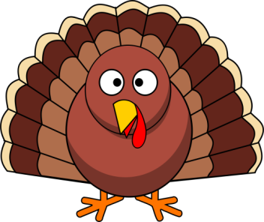

- Call to Order
- Attendance
- Review and Approval of agenda
- Secretary's Report
- Director’s Report
- Donations and Contributions
- Treasurer’s Report
- Approval of Expenditures and Incoming Checks
- Monthly Statistics
- Old Business:
- By Laws review
- Artist for tree
- Updated CPL COVID quotes
- New Business:
- Breakfast with Santa
- Gift Card for Friends
- 2021 Holiday Calendar
- Alarm Company quotes
- Plan next month’s agenda
- Next Meeting: December 15, 2020 at 6:30 pm
- Adjourn

