Chester Public Library
Board of Trustees Meeting
Tuesday, June 20th, 2017 6:00 PM
Agenda
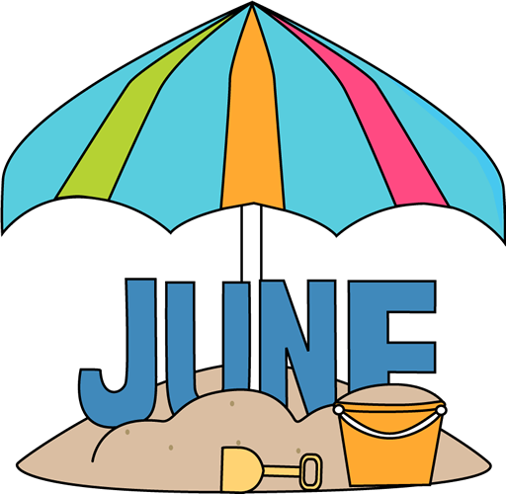

- Call to Order
- Review and Approval of Agenda
- Secretary's Report
- Director’s Report
- Donations and Contributions
- Treasurer’s Report
- Approval of Expenditures and Incoming Checks
- Monthly Statistics
- Unfinished business:
- Foundation Update
- Moriah Gavrish
- New Business:
- Elizabeth Kopacz Interior Designer
- Plan next month’s agenda
- Next Meeting: July 18th, 2017 at 6:00 pm
- Adjourn

