Chester Public Library
Board of Trustees Meeting
Tuesday September 18, 2018, 6:30 pm
Agenda
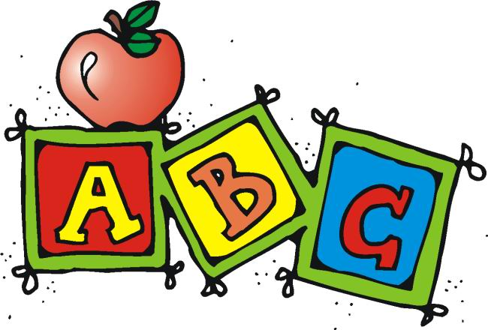

- Call to Order
- Review and Approval of agenda
- Secretary's Report
- Director’s Report
- Donations and Contributions
- Treasurer’s Report
- Approval of Expenditures and Incoming Checks
- Monthly Statistics
- Executive Session
- New Business
- Evaluations
- Unfinished business:
- Update on Foundation
- Bathroom sinks
- Plan next month’s agenda
- Next Meeting: October 16, 2018 at 6:30 pm
- Adjourn

